## A

Project Report on

## “PNEUMATIC SHEET METAL CUTTING MACHINE”

Submitted in partial fulfillment of the requirements

of the degree of Bachelor of Engineering in Mechanical Engineering

Submitted by

1. Gopal Aravandekar
2. Bhushan Bambulkar
3. Pranav Gawas
4. Tejas Kadam

Under the guidance of:

Prof. MESTRY M. P.





DEPARTMENT OF MECHANICAL ENGINEERING

S.S.P.M. COLLEGE OF ENGINEERING

Mumbai University

2020-2021



SSPM COLLEGE OF ENGINEERING

Harkul, Kankavli, Sindhudurg, Maharashtra – 416 602

DEPARTMENT OF MECHANICAL ENGINEERING

## CERTIFICATE

This is to certify that the project entitled **“PNEUMATIC SHEET METAL CUTTING MACHINE”** is a bonafide work of

**Name**

1. Gopal Aravandekar
2. Bhushan Bambulkar
3. Pranav Gawas
4. Tejas Kadam

**Roll No.**

01

02

14

20

submitted to the University of Mumbai in partial fulfillment of the requirement for the award of the degree of **Bachelor of Engineering** in **Mechanical Engineering**.

Project Guide External Examiner

(Prof. Mestri M. P.) (Name and Signature)

Head of Mech. Engg. Dept. Principal

(Prof. Sachin Vanjari) (Prof A. C. Gangal)

## **Project Report Approval for B. E.**

This project report entitled (**Pneumatic Sheet Metal Cutting Machine**) by (**Gopal Aravandekar, Bhushan Bambulkar, Pranav Gawas, Tejas Kadam**) is approved for the degree of (**Mechanical Engineering**).

Examiners

1.---------------------------------------------

2.---------------------------------------------

Date:

Place:

## Declaration

We declare that this written submission represents our ideas in our own words and where others' ideas or words have been included, We have adequately cited and referenced the original sources. We also declare that We have adhered to all principles of academic honesty and integrity and have not misrepresented or fabricated or falsified any idea/data/fact/source in our submission. We understand that any violation of the above will be cause for disciplinary action by the Institute and can also evoke penal action from the sources which have thus not been properly cited or from whom proper permission has not been taken when needed.

**Name**

1.Gopal Aravandekar

2.Bhushan Bambulkar

3.Pranav Gawas

4.Tejas Kadam

**Signature**

-

-

-

-

Date:

## 

## 

## ABSTRACT

We are using scissors for simple sheet metal cutting. It is a manual method so that sheet metals are to be wasted sometime because of mistakes happened such as wrong dimensions etc., and also even a simple cutting may take long time. Hydraulic machines are also available for sheet metal cutting. But this method is used for only heavy metal cutting and its cost is very high. We are using a pneumatic system for sheet metal cutting in a easy way. It is operated by a pneumatic hand lever of two way control valve. Control

valve is operated by a compressor.

Keywords: Sheet Metal, Pneumatic, Valve, Cutting Machine.

## 

## 

## 

## 

## 

## 

## 

## PREFACE

**“PNEUMATIC SHEET METAL CUTTING MACHINE”** is an interesting topic in the study of Engineering. We have tried to explain the various topics right from the fundamentals so that even a beginner can understand the details.

The first chapters give an introduction, problem and solution, project objectives.

The second chapters give a literature review etc.

The third chapter gives the construction and working principle.

The fourth chapter gives the detail of project design, component, specification,

working and images.

The fifth chapter gives costing and scheduling.

The sixth chapter gives problem faced,learning experience and calculation.

The seventh chapter gives result and discussion.

The eighth chapter gives conclusion and future scope.

At the end of the book, details on the cost of the project are given. Care has been taken to minimize error and typing mistakes, we would oblige to the reader for finding any error or mistake.

## TABLE OF CONTENTS

|  | Page No. |
| --- | --- |
| **CHAPTER 1. INTRODUCTION** | |
| 1.1 Introduction  1.2 Problem and Solution  1.3 Project Objectives | 01  04  04 |
| **CHAPTER 2. LITERATURE REVIEW** | |
| 2.1 Literature Review | 05 |
| **CHAPTER 3. PROJECT CONSTRUCTION AND WORKING PRINCIPLE** | |
| 3.1 Construction  3.2 Working Principle  3.3 Advantages | 08  09 |
| **CHAPTER 4. PROJECT DESIGN AND WORKING** | |
| 4.1 Design  4.2 Components  4.3 Specification  4.3 Project Working  4.4 Image | 13  19  20  22  23 |
| **CHAPTER 5. CALCULATION** | |
| 5.1 calculation | 27 |
| **CHAPTER 6. RESULT AND DISCUSSION** | |
| 6.1 Result  6.2 Discussion | 29  29 |
| **CHAPTER 7. COSTING AND SCHEDULING** | |
| 7.1 Costing  7.2 scheduling | 30  31 |
| **CHAPTER 8. GENERAL CONCLUSIONS** | |
| 8.1 Conclusions  8.2 Problem Faced  8.3 Learning Experience  8.4 Future Scope | 32  32  32  33 |
| **LITERATURE CITIES** | |
| References  Paper Publish | 34  35 |
| **ACKNOWLEDGEMENT** | |

## CHAPTER 1. INTRODUCTION

### 1.1 INTRODUCTION:

The sheet cutting machine is the heart of sheet metal industries. In some industries, hand sheet cutter is used which is operated manually. In these machine, we are using a pneumatic cylinder for sheet metal cutting. These machine should be easy to operate and maintain also. Hence, we are introducing a pneumatic sheet metal cutting machine which will reduce manufacturing cost and minimize industrial labor problems which is the biggest headache for human.

Sheet metal is simply a metal formed into thin and flat pieces. It is one of the fundamental forms used in metalworking and can be cut and bent into a variety of different shapes. Countless everyday objects are constructed of the material. Thicknesses can vary significantly, although extremely thin thicknesses are considered foil or leaf, and pieces thicker than 6 mm (0.25 in) are considered plate. Sheet metal is available in flat pieces or as a coiled strip. The coils are formed by running a continuous sheet of metal through a roll slitter. The thickness of the sheet metal is called its gauge. Commonly used steel sheet metal ranges from 30 gauge to about 8 gauge. The larger the gauge number, the thinner the metal. Gauge is measured in ferrous (iron based) metals while nonferrous metals such as aluminum or copper are designated differently; i.e., Copper is measured in thickness by ounce. There are many different metals that can be made into sheet metal, such as aluminum, brass, copper, steel, tin, nickel and titanium. For decorative uses, important sheet metals include silver, gold and platinum (platinum sheet metal is also utilized as a catalyst). Sheet metal also has applications in car bodies, airplane wings, medical tables, roofs for buildings (Architectural) and many other things. Sheet metal of iron and other materials with high magnetic permeability, also known as laminated steel cores.

**Sheet Metal**

Sheet metal is metal formed by an industrial process into thin, flat pieces. Sheet metal is one of the fundamental forms used in metal working and it can be cut and bend into a variety of shapes. Countless everyday objects are fabricated from sheet metal. Thicknesses can vary significantly, extremely thin sheets are considered foil or leaf. In most of the world, sheet metal thickness is consistently specified in millimeters. There are many different metals that can be made into sheet metal, such as aluminium, brass, copper, steel, tin, nickel & titanium.

**Uses of Sheet Metal**

Sheet metal is used in automobile & truck bodies, airplane fuselages & wings, medical tables, roofs for buildings. For decorative uses, some important sheet metals include silver, gold & platinum (platinum sheet metal is also utilized as a catalyst).

**Difficulties in Sheet Metal Cutting Operations**

Sheet metal cutting operations involve the separation of the metal of the sheet in certain areas. This separation is caused by shearing forces acting on the metal through the edges of the punch & die. Blanking is the cutting of sheet metal part along a closed counter in one step. The piece cut out is called blank. Many blanks are often continuously cut out of a sheet or strip. This blanking will waste a certain amount of material.

Clearance is an important factor in the design of sheet metal cutting process. More clearance than required causes the sheet metal to get forced between the cutting edges. Fractures occurs incorrectly & the resulting edge is usually not desirable. Edge surface of cut sheet metal are not typically smooth & straight.

**Types of Sheet Metal Cutting Operations-**

(1) Shearing Operation,

(5) Punching Operation,

(2) Slotting Operation,

(6) Notching Operation,

(3) Bending Operation,

(4) Blanking & Fine Blanking Operation,

**Pneumatics**

It is a branch of engineering that makes use of gas or pressurized air. Pneumatic system used in industry are commonly powered by compressed air or compressed inert gases. A pneumatic system controlled through manual or automatic solenoid valve. Pneumatics also has applications in construction, mining, automobile, etc.

**Benefits of Pneumatic Control Systems-**

∙ **Efficient**- The atmosphere contains an unlimited supply of air for the production of compressed air, which can be easily stored in large volumes. Not only can compressed air be easily transported through pipes but after it’s been used it can be released directly into the atmosphere without any further processing.

∙ **Reliable**-Pneumatic system components are extremely durable & reliable. Compared to electromotive components, pneumatic parts are proven to last longer & required less maintenance.

∙ **Simple**-Pneumatic systems components are relatively simple, which makes them suitable for less complicated automatic control systems.

**Evolution of the Process of Cutting & Deformation of Sheet Metal**

Hand hammered metal sheets have been used since ancient times for architectural purposes. Water-powered rolling mills replace the manual process in the late 17th century.

With the birth of industrial revolution & increase in demand of sheet metal fabrication, manufacturers were able to develop new invitation like press brakes & assembly line, increasing the production of higher quality parts.

∙ Around 1485: Leonardo da Vinci draws a sketch of rolling mill, which is very advanced for the time.

∙ Around 1501: There are two reports of two rolling mills. One is used to obtain gold sheets with uniform thickness from which to draw coins while the other is used to cut previously formed sheets into strips.

∙ Around 1615: The first industrial plant produces lead & tin plates.

∙ Around 1760: The industrial revolution created a surge of sheet metal work. With new inventions like the assembly lines & press brakes, sheet metal workers of past can produce a higher quantity of parts and projects.

∙ Around 1783: English industrialist Joseph Bramah develops the hydraulic press.

∙ Around 1851: The British Great Exposition shows a piece of sheet metal more than 6-meter in length, 1-meter in width & 11-mm thickness that weights 500 kg.

The sheet metal industry has transformed over time from the sketch of genius to a billion dollar industry and it’s still evolving.

### 1.2 PROBLEMS AND SOLUTIONS:

**Problem & Solution:**

The sheet cutting machine is the heart of the sheet metal industries. In some industries, hand sheet cutters are used which are operated manually and less accurate. Manual cutting machines require a lot of manual effort and are also not suitable for bulk cutting processes with accuracy. Hence, we are introducing a pneumatic sheet metal cutting machine; the machine should be easy to operate and maintain also, which will reduce manufacturing cost and minimize industrial labor problems. If we use the machine, the work will be completed in time as compared to the previous situation.

### 1.3 PROJECT OBJECTIVES:

1. The main objectiveof our projectis to perform job holding operations effectively with less human effortby using a machine with pneumaticpower.
2. Next objective is to reduce the time required for metal cutting.
3. By using these machines we can increase the production rateand automatically the industry will be in profit.

## CHAPTER 2. LITERATURE REVIEW

### 2.1 LITERATURE REVIEW:

#### [1]Design and Fabrication of Pneumatic Sheet Metal Cutting Machine.

Normally the sheet metal cutting machine is manually hand operated for medium and small scale industries. Any automatic machine aimed for economical use of man. In this project, pneumatic cylinder is used for cutting in easy way which can be used in small scale industries at lower cost. The sheet metal cutting machine works with the help of pneumatic double acting cylinder.The main advantage of pneumatic sheet metal cutting machine is to improve product quality, repetition of work and increasing production rate. In cutting operation as or blade descends upon the metal, the pressure exerted by the blade first caused the plastic deformation of the metal, since the clearance between to blade is very small. The plastic deformation takes place in localize area and the metal adjacent to the cutting edges of the blade edges become highly stress, with courses the facture to start on both side of the sheet as the deformation progresses and sheet is shear.

#### [2] FABRICATION OF A PNEUMATIC SHEET METAL CUTTING MACHINE.

Sheet metal is simply a metal formed into thin and flat pieces. It is one of the fundamental forms used in metal working and can be cut and bent into a variety of different shapes. Countless everyday objects are constructed of the material. Thicknesses can vary significantly, although extremely thin thicknesses are considered foil or leaf, and pieces thicker than 6 mm (0.25 in) are considered plate. Sheet metal also has applications in car bodies, airplane wings, medical tables, roofs for buildings (Architectural) and many other things.

The most common cutting processes are performed by applying a shear force, and are therefore sometimes referred to as shearing processes. Cutting processes are those in which a piece of sheet metal is separated by applying a great enough force to cause the material to fail .When a great enough shearing force is applied, the shear stress in the material will exceed the ultimate shear strength and the material will fail and separate at the cut location.

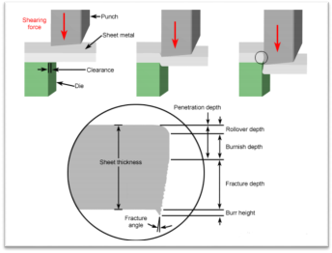

Fig 2.1.1: Sheet metal cutting operation

#### [3] FABRICATION OF PNEUMATIC SHEET METAL SHEARING MACHINE

In cutting operation as or blade descends upon the metal, the pressure exerted by the blade first caused the plastic deformation of the metal, since the clearance between to blade is very small. The plastic deformation of the metal, since the clearance between to blade is very small. The plastic deformation takes place in localize area an d the metal adjacent to the cutting edges of the blade edges become highly stress, with courses the fracture to start on both side of the sheet as the deformation progresses and sheet is shear.

#### [4] Fabrication of Pneumatic Sheet Metal Cutter.

The reason for using pneumatics, or any other type of energy transmission on a machine, is to perform work. The accomplishment of work requires the application of kinetic energy to a resisting object resulting in the object moving through a distance. In a pneumatic system, energy is stored in a potential state under the form of compressed air. Working energy (kinetic energy and pressure) results in a pneumatic system when the compressed air is allowed to expand.

#### [5] Automated Pneumatic Sheet Metal Cutting Machine.

Automated pneumatic sheet metal cutting has been used to shear the sheets made of galvanized iron and aluminium of various thicknesses. The pressure and force required for shearing these metal sheets have been listed accordingly. Automation in the process is incorporated by using microcontroller, inductive proximity sensor, electrically controlled solenoid valve and DC motor controlled roller feed system. The automation provides provision to enter the number of sheets to be cut and required length of the sheet.The system works by pneumatic means which consists of air compressor, pipe lines, control valves and pneumatic cylinder. The design is particularly suited for the applications where working space is constrained. Pneumatic systems are useful when sheet metals are need to be cut in hazardous areas such as oil and gas refineries and in chemical factories. Further it is observed that, the employment of automation system makes the cutting process accurate, time efficient and increases the productivity as compared to conventional non-automated

cutting machine.

#### [6] Design and Fabrication of Pneumatic Sheet Metal Cutting and Punching Machine.

Metal in the form of sheets is paramount in the manufacturing industry. Its applications are countless. But metal in the form of sheets cannot be directly used, operations like cutting, punching, blanking, bending, trimming, etc. are needed to be carried out on the metal sheets in order to fully utilize them. For these operations, most large scale manufacturing industries use hydraulically operated machines. But since hydraulic machines are not cost-effective, most small and medium scale industries use hand-operated machines for carrying out sheet metal operation. The problem with hand-operated machines is that they are slow and cannot be automated. This is where the concept of pneumatics will prove itself advantageous. We are developing a pneumatically operated cutting machine which will use the help of compressed air to drive a shearing blade, to carry out the operations on a metallic sheet.

#### [7] Pneumatic Sheet Metal Cutting Machine.

Hydraulic machines are also available for sheet metal cutting. But this method is used for only heavy metal cutting and its cost is very high. We are using a pneumatic system for sheet metal cutting in a easy way. It is operated by a pneumatic hand lever of two ways control valve. Control valve is operated by a compressor. In shearing or cutting operation as or blade descends upon the metal, the pressure exerted by the blade first cause the plastic deformation of the metal. Since the clearance between the two blades is very small, the plastic deformation takes place in a localized area and the metal adjacent to the cutting edges of the blade edges becomes highly stressed, which causes the fracture to start on both sides of the sheet as the deformation progresses and the sheet is sheared.

## CHAPTER 3. PROJECT CONSTRUCTION & WORKING PRINCIPLE

### 3.1 CONSTRUCTION:

#### 3.1.1 Raw Material Used-

[1] Mild Steel bars for base frame.

[5]Connecting link,

[2]35C8 material for shearing blades,

[6]Blade link,

[3]Angle section for blade fitting,

[4]Cylinder fittings like fork end, base plates, support links,

#### 3.1.2 Ready Items Used-

[1] Pneumatic double acting cylinder,

[4]Bolts & nuts,

[2] Direction & flow control valves,

[5] Anti-Rust coat & paint,

[3] Pneumatic pipe & pipe fittings,

#### 3.1.3 Machines & Tools Used-

[1] Cutting Machine,

[2] Electric Arc Welding Machine,

[3] Hacksaw Cutting Machine,

[4] Sensitive Drilling Machine,

[5] Horizontal Milling Machine,

[6] Surface Grinding Machine,

[7] Table Grinder,

[8] Hand Grinder,

### 3.2 WORKING PRINCIPLE:

The following figure shows the general layout for the machine. 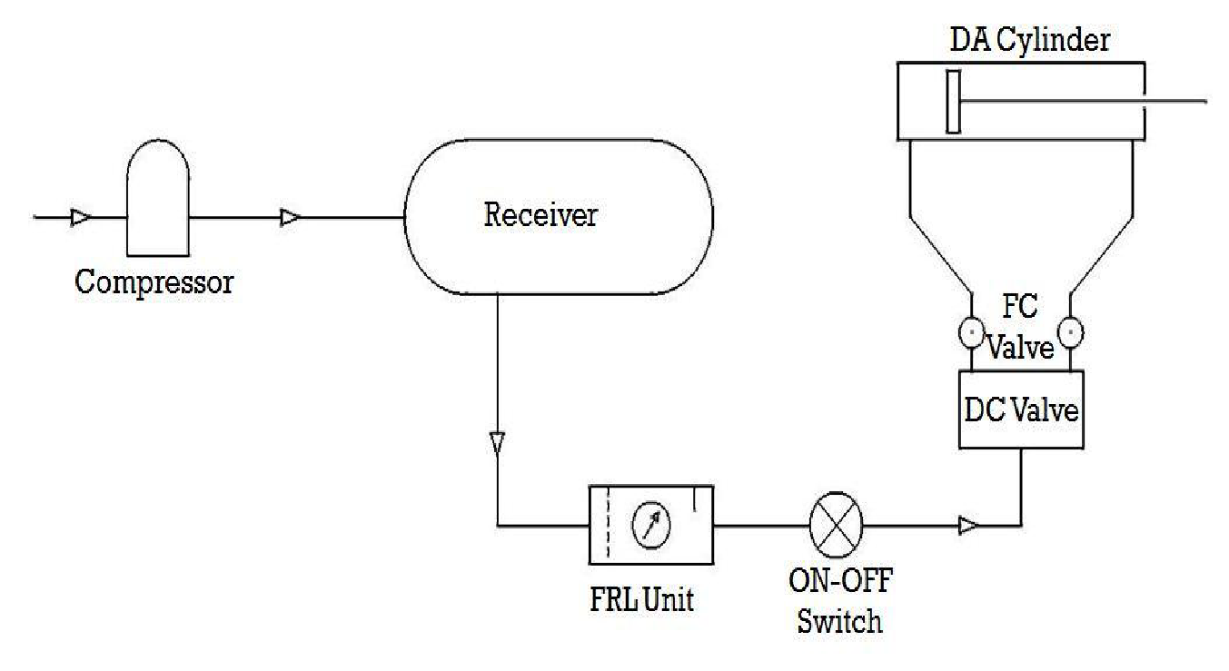

Fig.3.2.1

Initially the air-compressor was started and allowed the receiver tank air pressure to reach up to 8 bar. The supply air is then passed to the manifold through the FRL unit to condition the air and be eligible for industrial use.

From the manifold a separate supply for the machine is taken out and given to ON-OFF switch, so as to operate the machine at will without interrupting the running of the compressor.

Then the pipe carries compressed air first to the machine's Direction Control Valve. At position ‘A’ shows the non-actuated circuit diagram. At this position the piston is steady and locked. All ports are in closed condition.

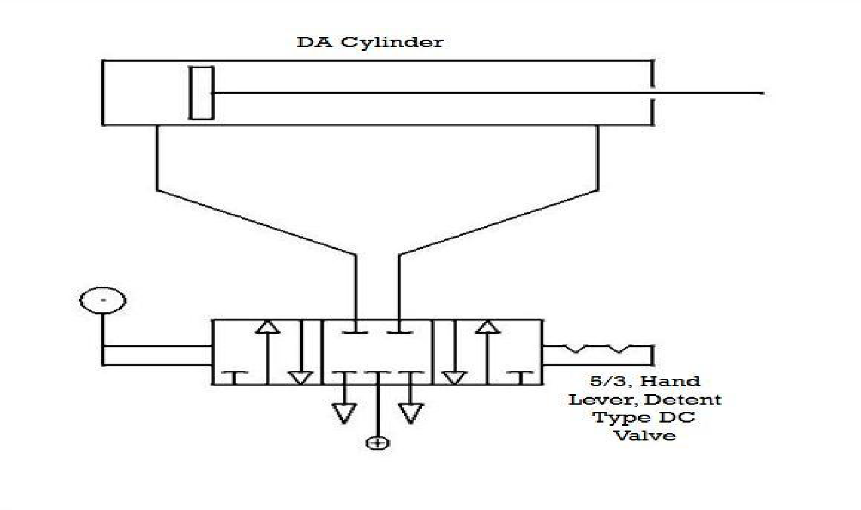

Fig 3.2.2 POSITION ‘A’

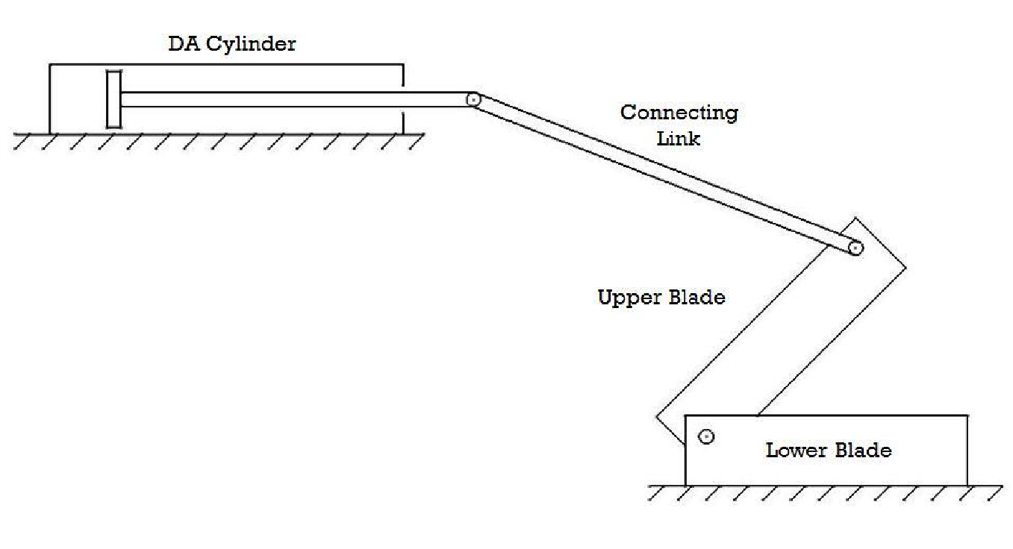

fig. 3.2.3

At position ‘B’, the DC valve is at left hand position as shown in figure. The cap end port & pressure port get connected to each other and the rod end port gets connected to the exhaust port. The compressed air comes in the cap end of the cylinder and pushes the pistons outwards. The air already present in the rod end side is pushed out of the cylinder.

When the piston moves outwards, the force is transmitted through the connecting link and the upper blade moves downwards. Before the actuating DC valve the sheet is inserted in

between the upper & lower blades. As the upper blade moves downwards, the stress is generated in the sheet metal and goes beyond ultimate shear stress of sheet metal. And thus the shearing action takes place.

Now the DC valve is operated to come at position ‘C’, as shown in figure. The rod end port & pressure port get connected to each other and the cap end port gets connected to the exhaust port. The compressed air comes in the rod end of the cylinder and pushes the pistons inwards. The air already present in the cap end side is pushed out of the cylinder.

The sheet metal is either again inserted for further cutting in case of large pieces; the small cut pieces are removed and the next sheet is inserted to cut.

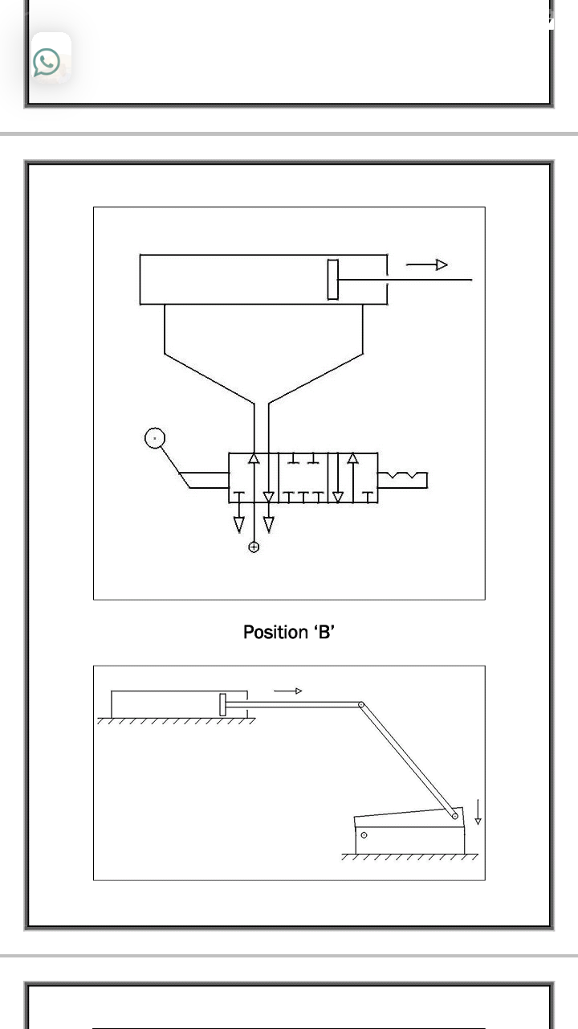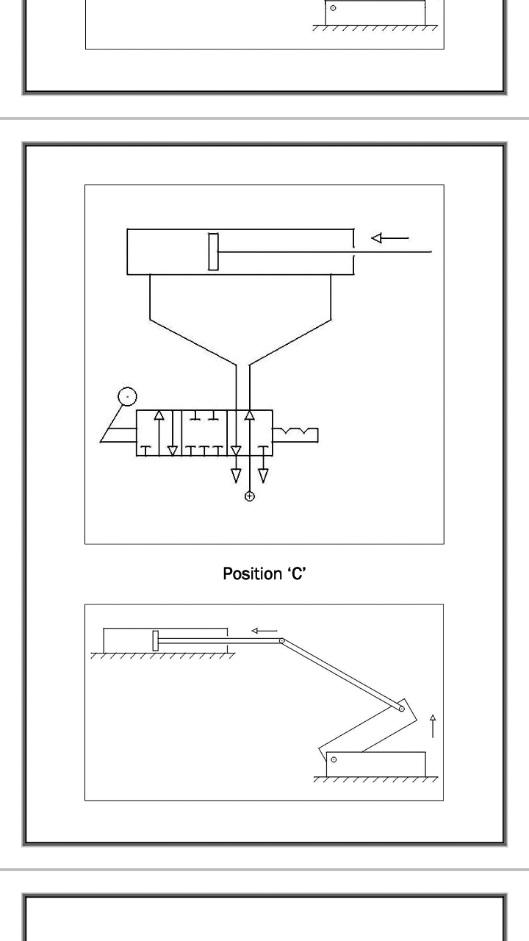

fig.3.2.4.

### 

### 

### 3.3 ADVANTAGES:

1. Hydraulics present certain advantages over pneumatics, but in a given application, pneumatic powered equipment is more suitable, particularly in industries where the factory units are plumbed for compressed air.
2. Moreover, to avoid corrosive actions, oil or lubricants are added so that friction effects can be reduced.
3. Compressed air is used in most of the machines and in some cases compressed carbon dioxide, whereas cutting process is become easy.
4. Fast cutting action is carried out.
5. Cutting without bending is achieved.
6. Sheet metals are used in
   1. Car bodies
   2. Airplane wings
   3. Medical tables
   4. Roofs for buildings (Architectural) and many other things

## CHAPTER 4. PROJECT DESIGN AND WORKING

### 4.1 DESIGN:

* Base frame is designed such that the pneumatic cylinder is above the shearing blade therefore the piston gives maximum force and sheet metal is easily cut.
* As shown in figure pneumatic double acting cylinder placed on the base frame. At the end of the pneumatic cylinder fork end is attached and the connecting rod tightens by nut and bolt.
* Another end of the connecting rod is connected to the shearing blade which connects the shearing blade and the pneumatic cylinder. Shearing Blade and connecting rod tightened by nut and bolt.
* Shearing Blade and angle section are tightened by nut and bolt. Angle Section is welded to the base frame. As shown in Fig.4.1.
* Pneumatic cylinder port is connected to the 5/2 direction control valve by pipe. As shown in fig.4.1 and Direction control valve connected to the air compressor.

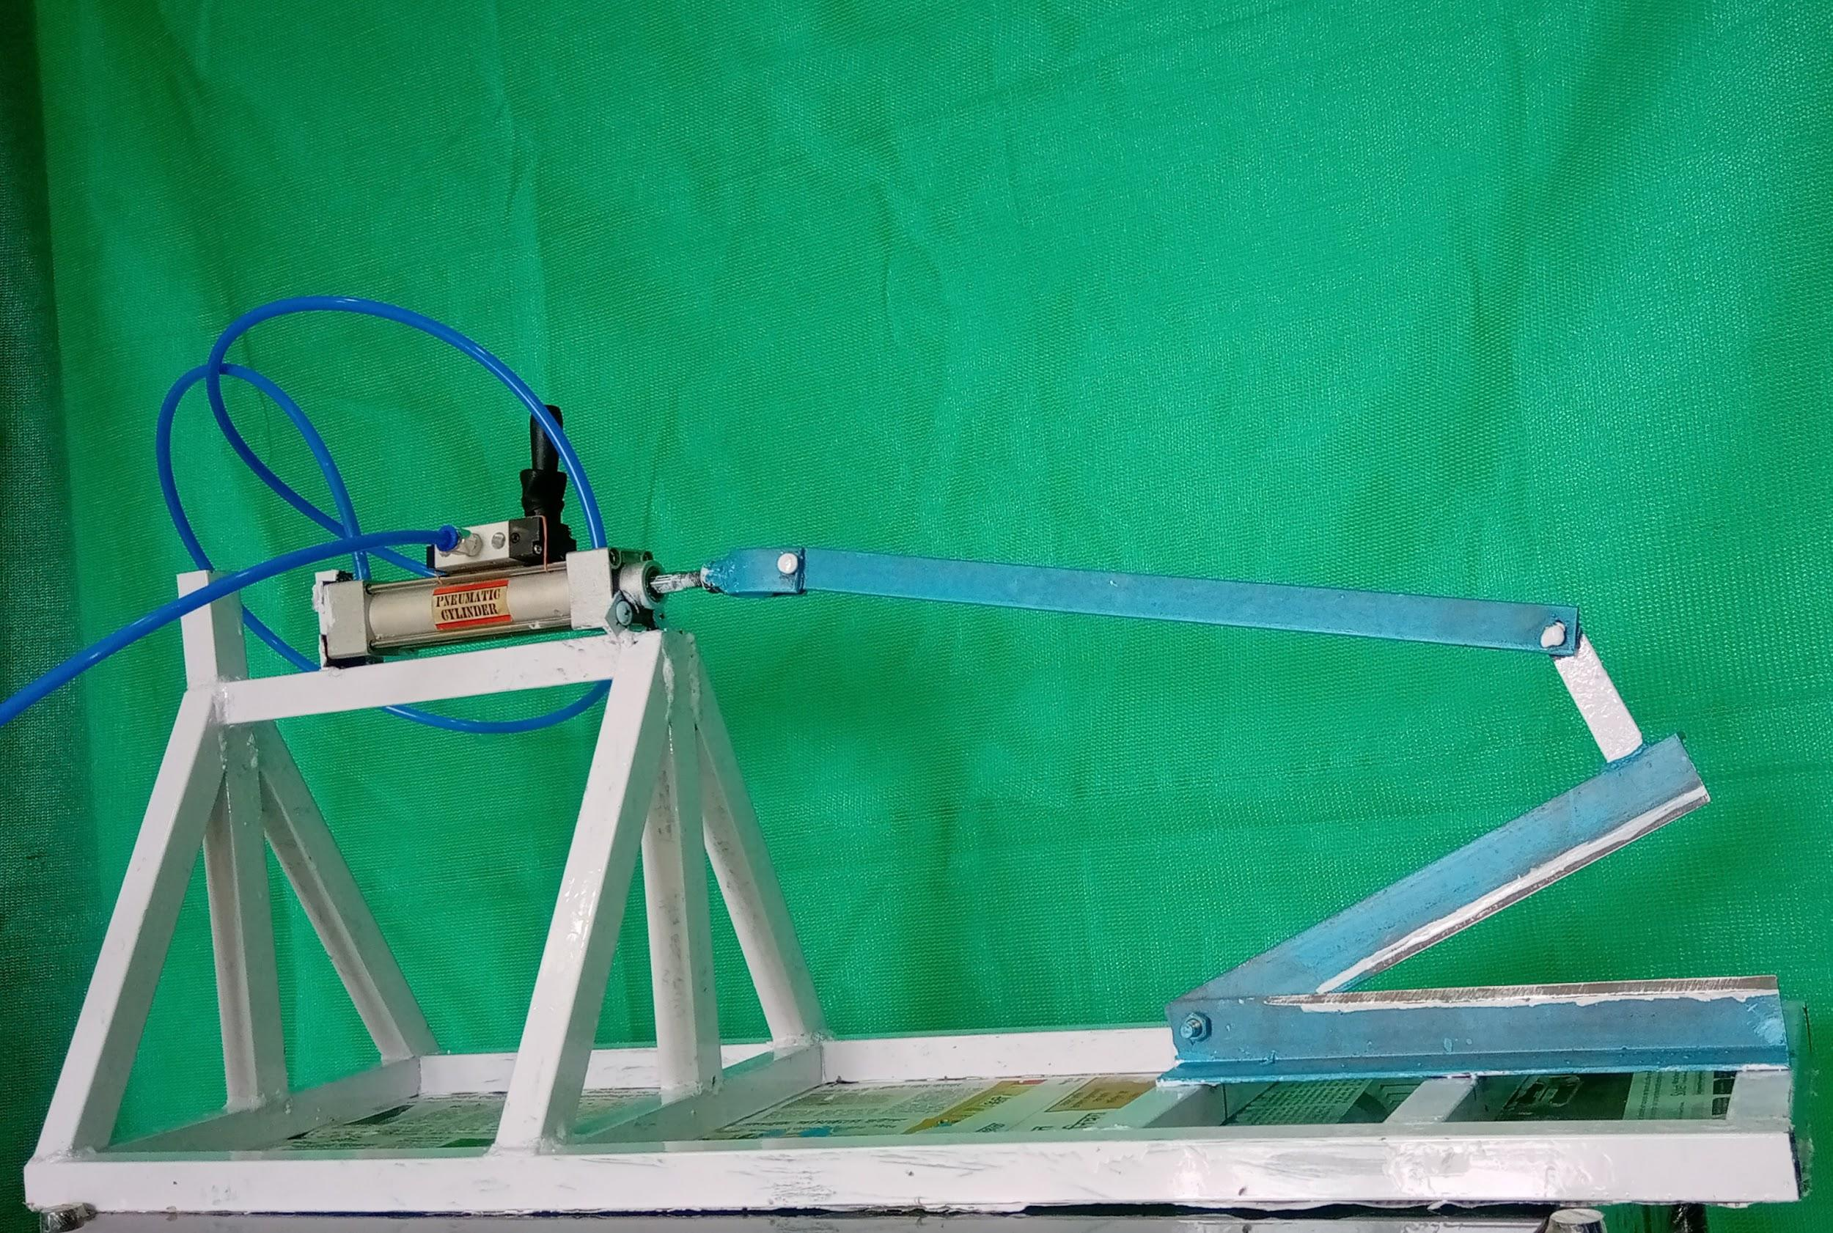

fig.4.1.

**4.1.1. 3D models:**

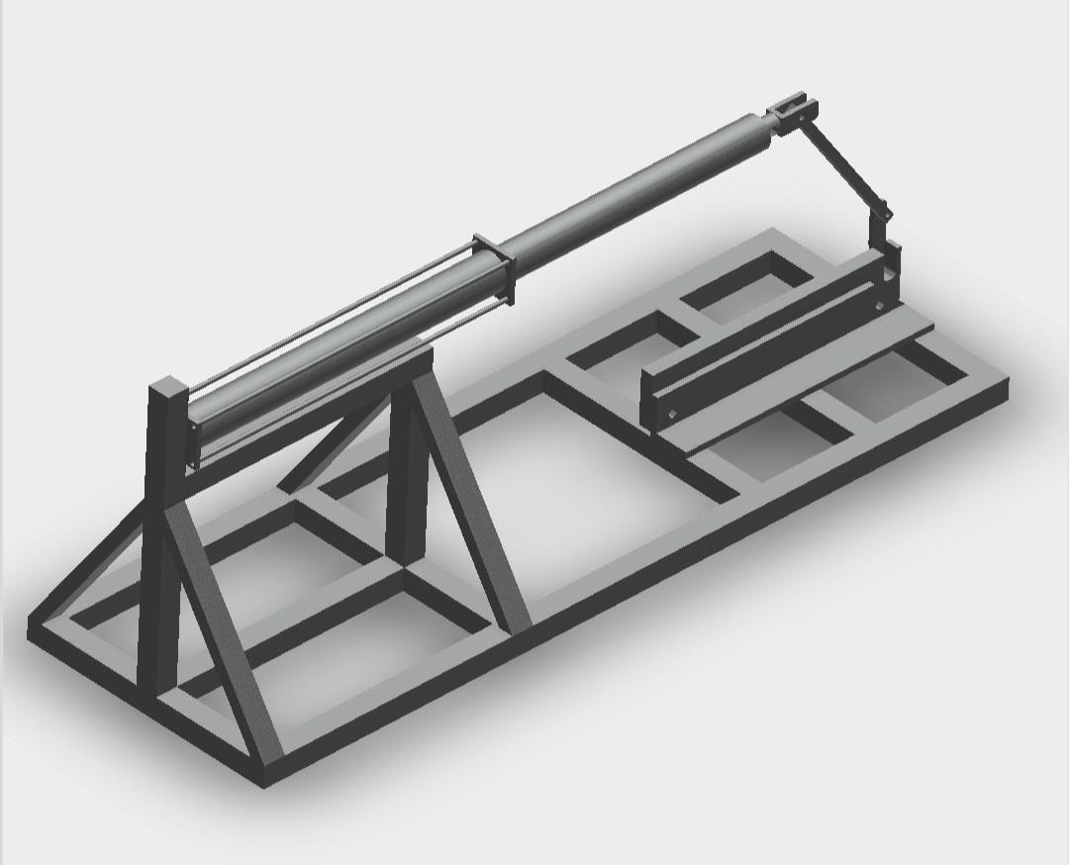

fig.4.1.1.

#### 4.1.2.Base Frame:

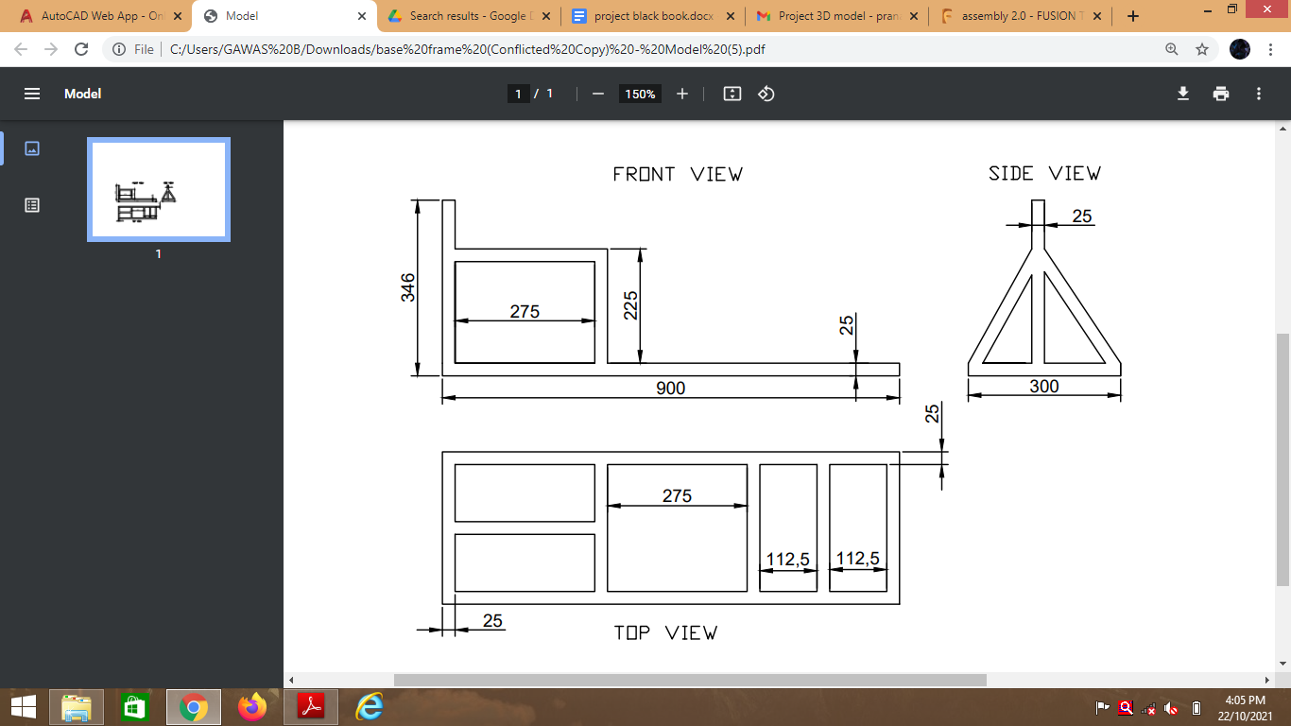

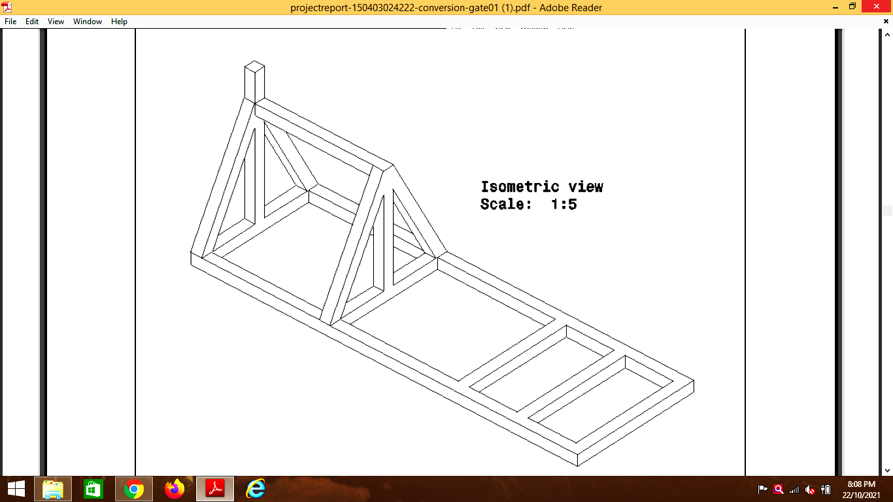

fig.4.1.2.

#### 4.1.3. Shearing Blade:

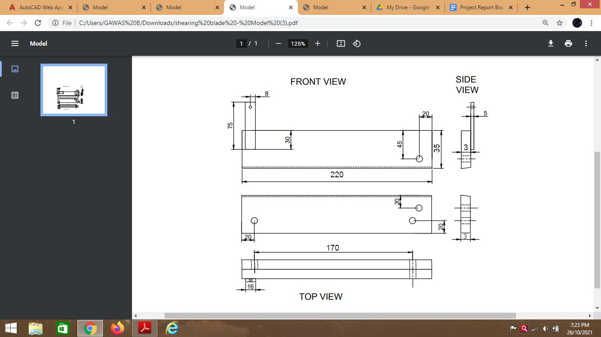

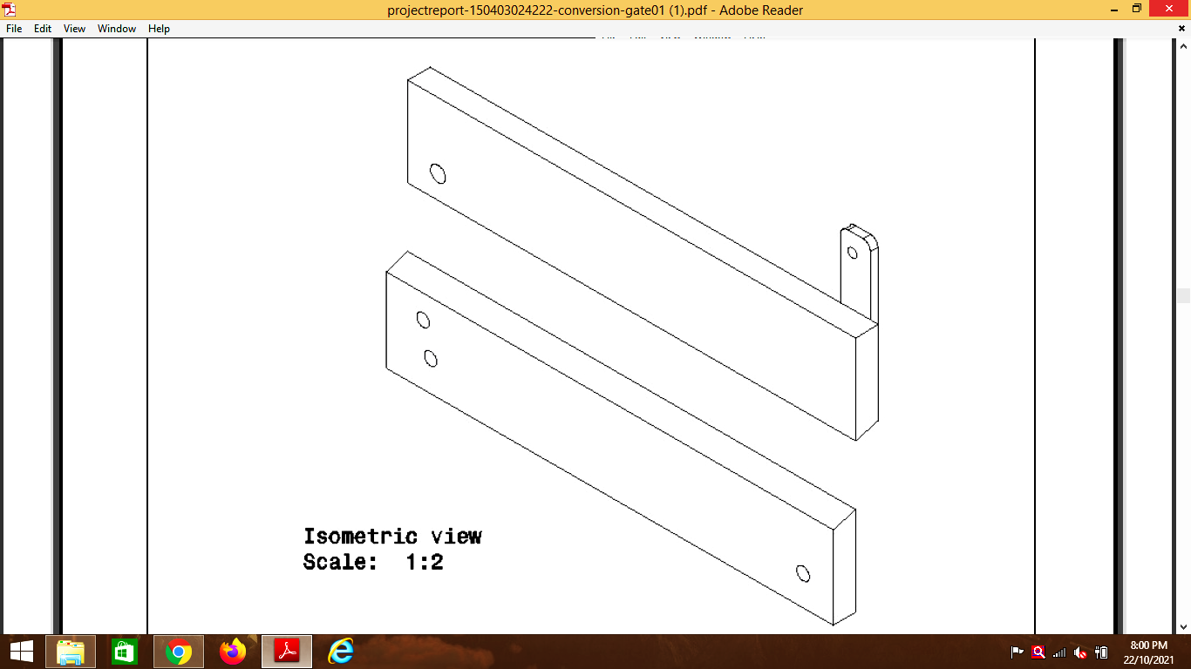

fig.4.1.3.

#### 4.1.4. Angle Section:

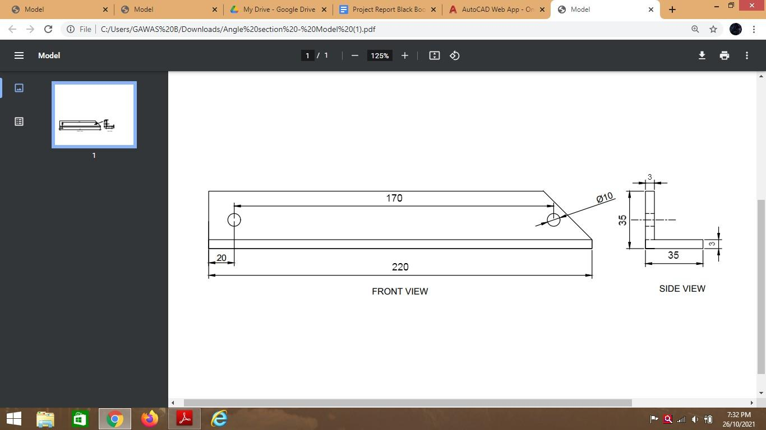

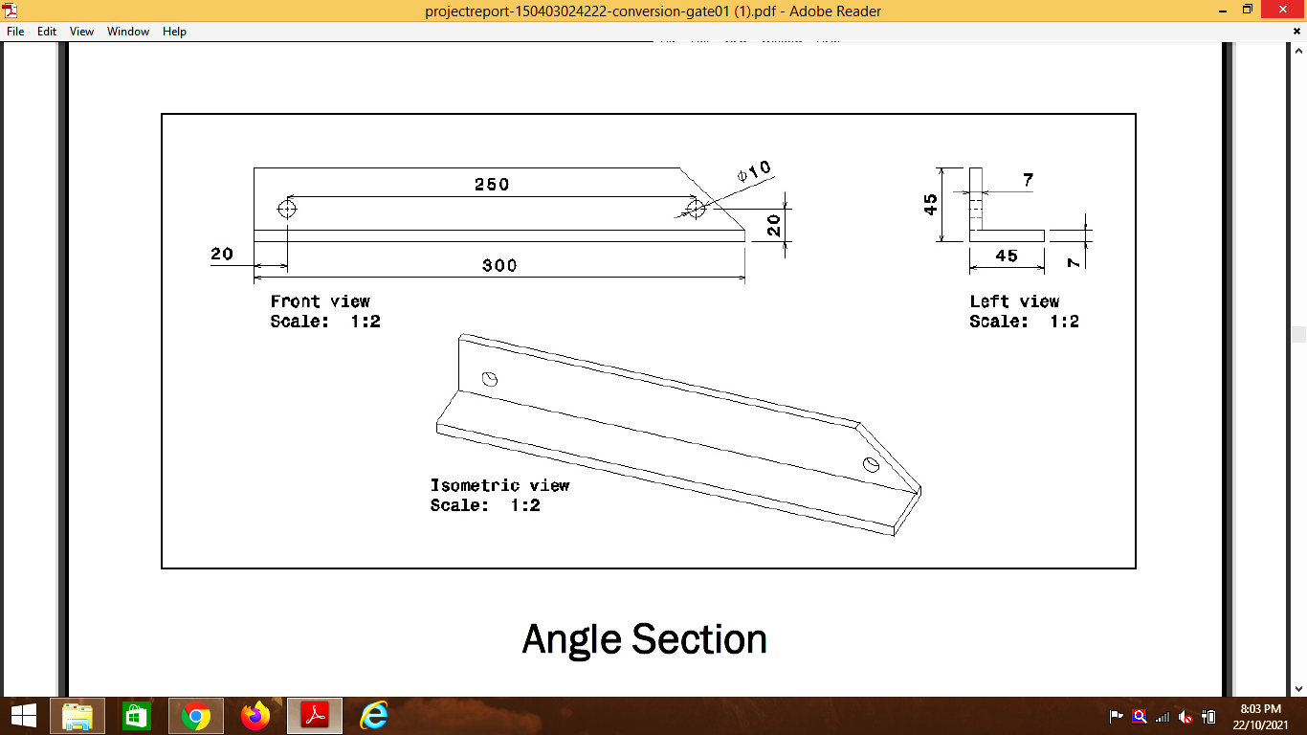

fig.4.1.4.

#### 4.1.6. Connecting Link:

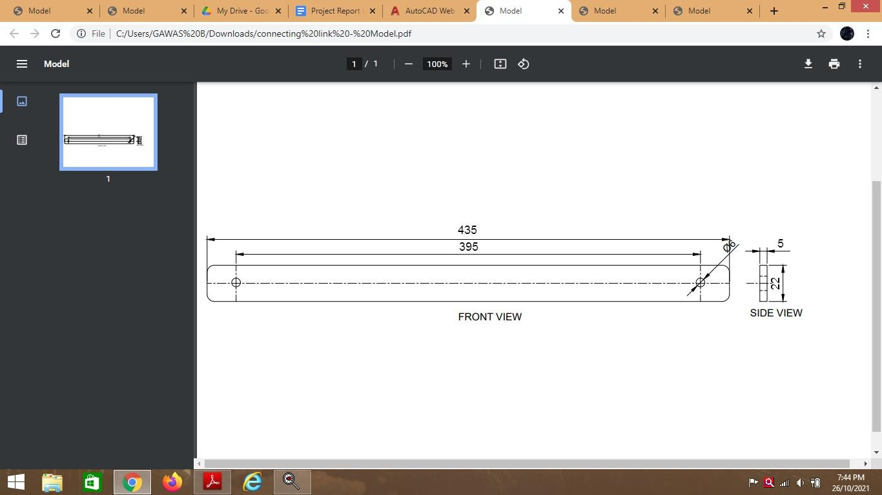

fig.4.1.6.

#### 4.1.7. Fork End:

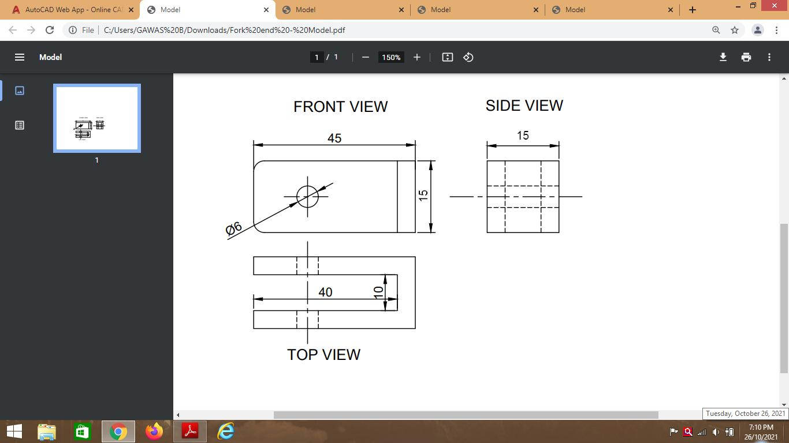

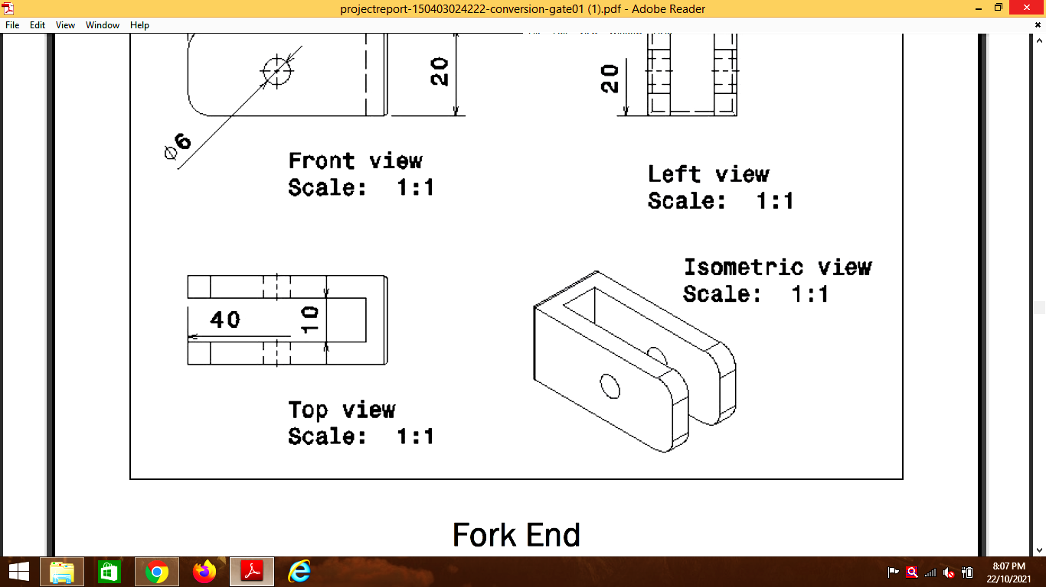

fig.4.1.7.

### 4.2 COMPONENTS:

#### 4.2.1. Base Frame

Quantity: 1

Height: 300mm

Length: 900mm

Width: 300mm

Weight: 1.5kg

#### 4.2.2. Shearing Blade

Quantity: 2

Length: 220 mm

Height: 35mm

Thickness: 3mm

Blade Angle: 20o

Weight: 0.5kg

#### 4.2.3. Fork End

Quantity: 1

Length: 45mm

Width: 15mm

Thickness: 2mm

#### 4.2.4. Angle Section

Quantity: 1

Height: 300mm

Length: 220mm

Width: 35mm

Thickness: 3mm

Weight: 0.5kg

#### 4.2.5. Connecting Link

Quantity: 1

Length: 435mm

Thickness: 5mm

Height: 22mm

Weight: 0.15kg

#### 4.2.6. Support Links

Quantity: 2

Height: 30mm

Width: 30mm

Thickness: 2mm

#### 4.2.7. Blade Link

Quantity: 1

Height: 75mm

Width: 20mm

Thickness: 2mm

Welded Length: 20mm

### 4.3 SPECIFICATIONS:-

#### 4.3.1. Pneumatic Cylinder

Quantity: 1

Total Length: 200mm

Bore: 32mm

Stroke: 100mm

Piston Rod Diameter: 15mm

Max Working Pressure: 831.5 N

Weight: 1.2kg

#### 4.3.2. DC Valve

Quantity: 1

Operation: Manual

Type: Hand Lever, Detent Type

Number of Ports: 5

Number of Positions: 2

Construction: Sliding spool type

#### 4.3.3. Pneumatic Pipe

Length: 3000mm

Diameter: 8mm

Thickness: 1mm

#### 4.3.4. Fork End Nut :

Quantity: 2

Length: 5mm

Size: 12

#### 4.3.5. Cylinder Base Plate Bolts Quantity: 4

Length: 20mm

Size: 12

#### 4.3.6. Blade Fixing Bolts Quantity:3

Length: 20mm

Size: 12

#### 4.3.7. Connecting Link Bolts Quantity: 2

Length: 20mm

Size: 12

### 4.4. PROJECT WORKING:

* As shown in Fig,4.4. after completing the model we started the air compressor and connected the model via pipe. Therefore, compressed air flows through the pipe.
* Direction control valve operates the direction of flow of compressed air, with the help of direction control valve piston moves forward and backwards.
* Then we put the sheet metal of 5mm thickness placed on the shearing blades, with the help of a control valve piston moves forward and connecting rod connected to the shearing blade. Therefore, the shearing blade moves downwards and cuts sheet metal.
* By direction control the valve piston moves to the original position of the hand lever.

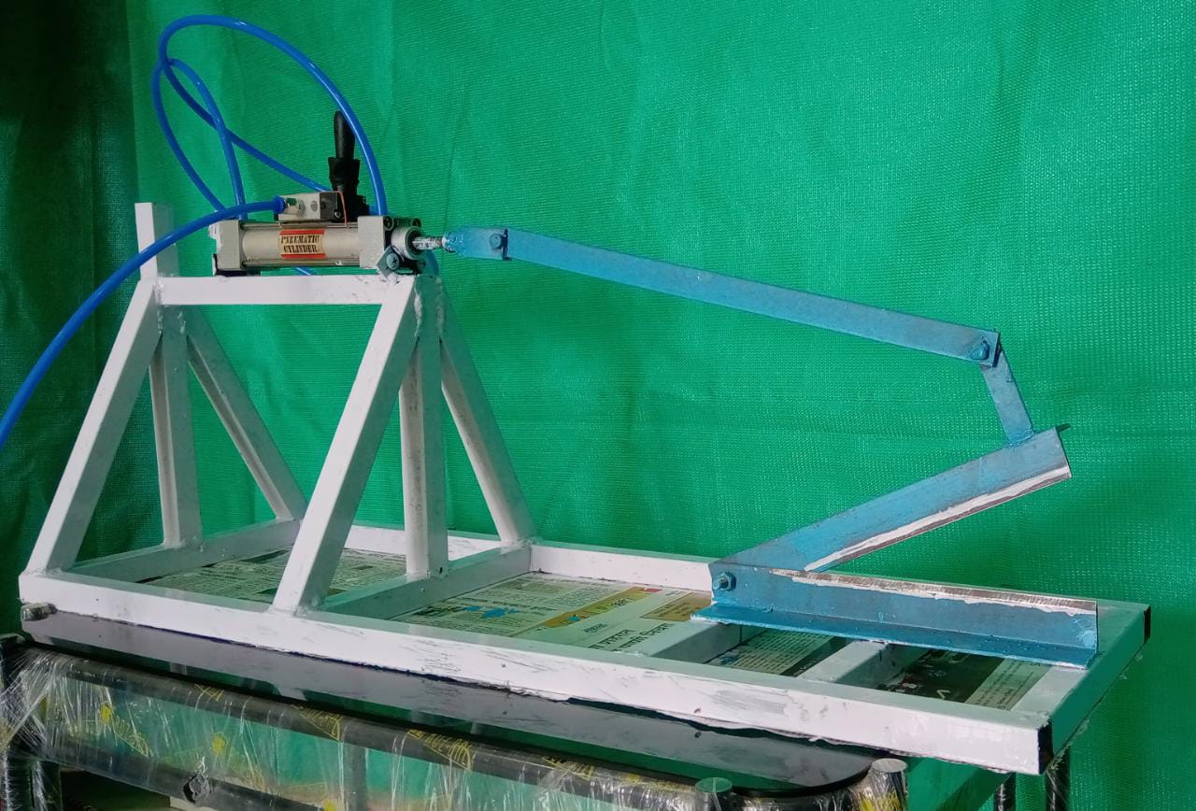

fig.4.4.

### 4.5 IMAGES:

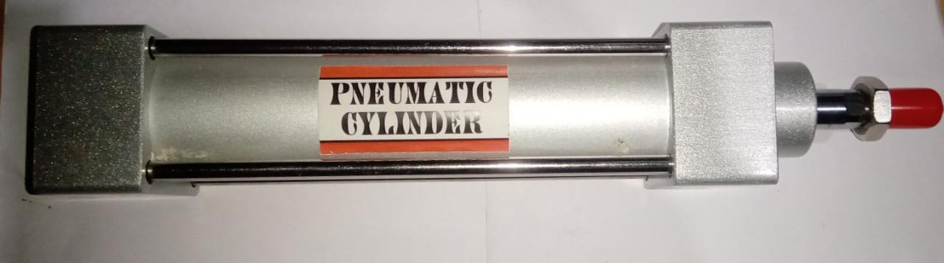

#### 4.5.1. Double Acting Cylinder

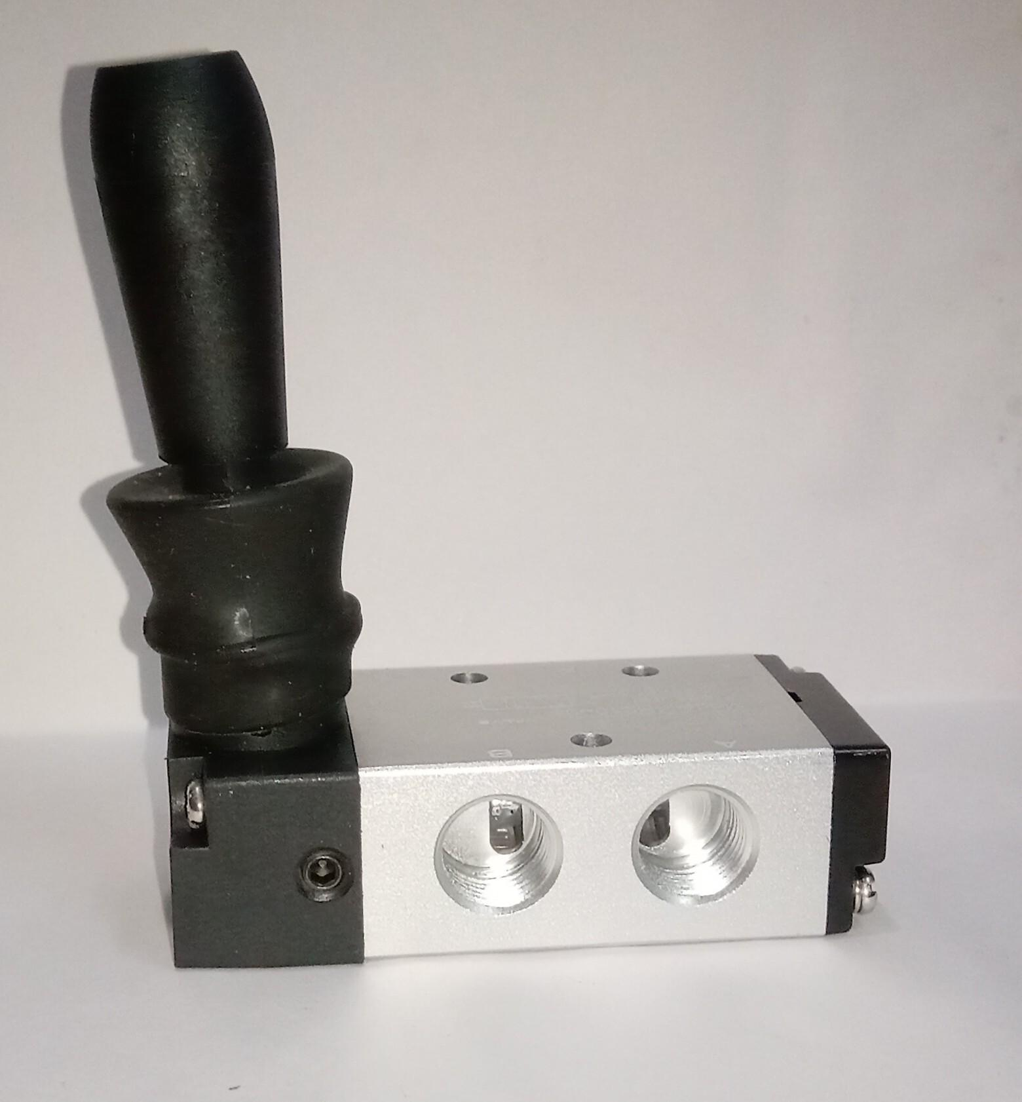

**4.5.2. Direction Control Valve**

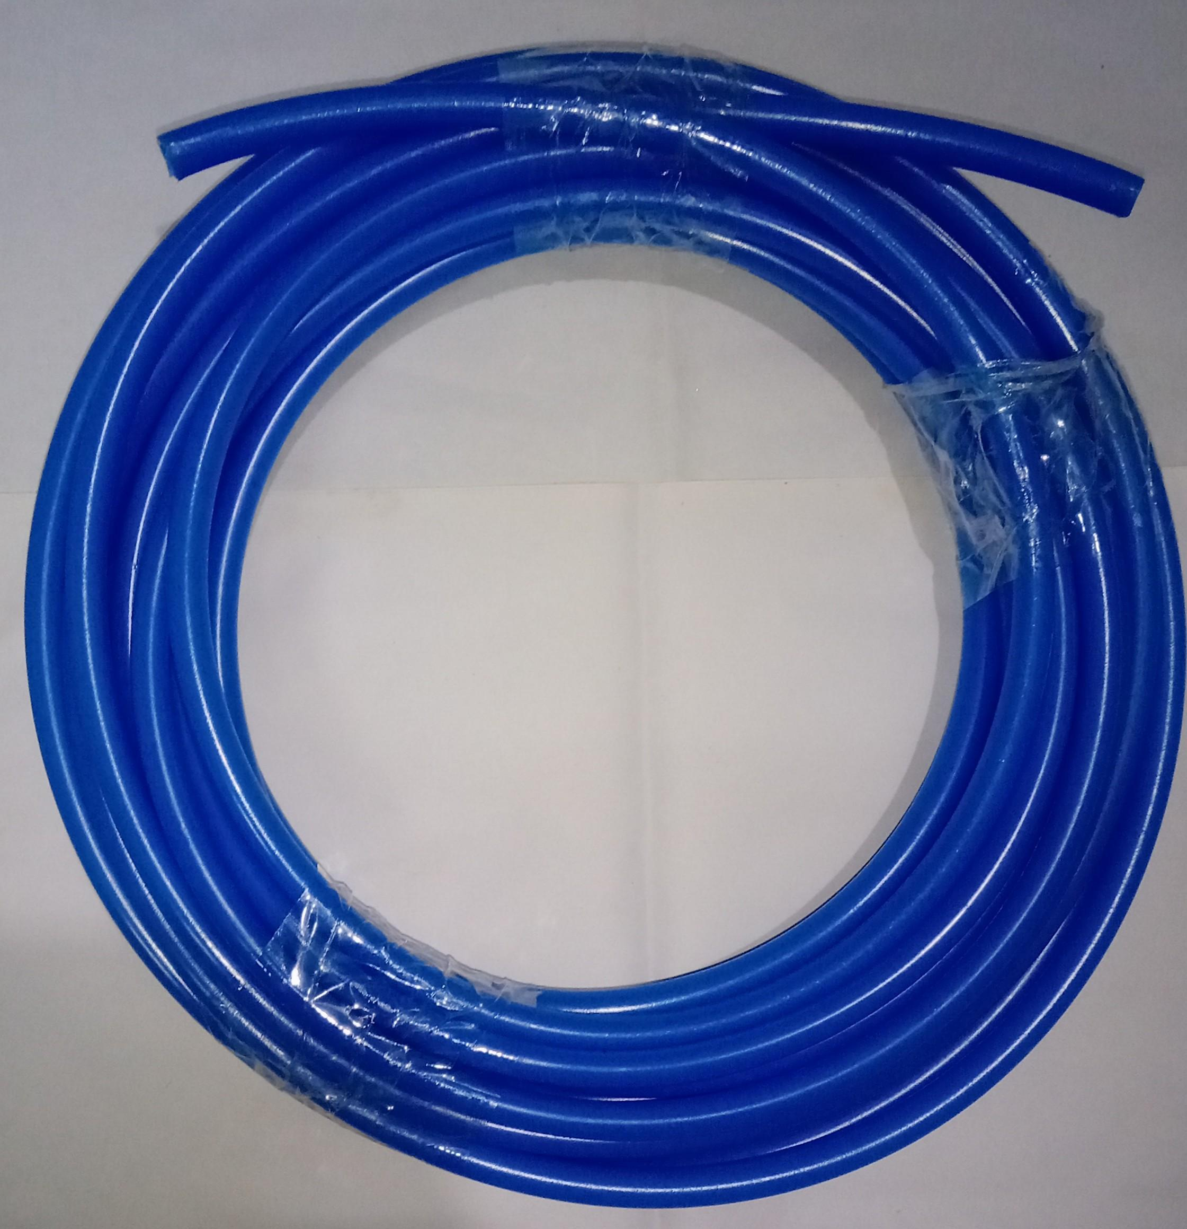

#### 4.5.3. Pipe

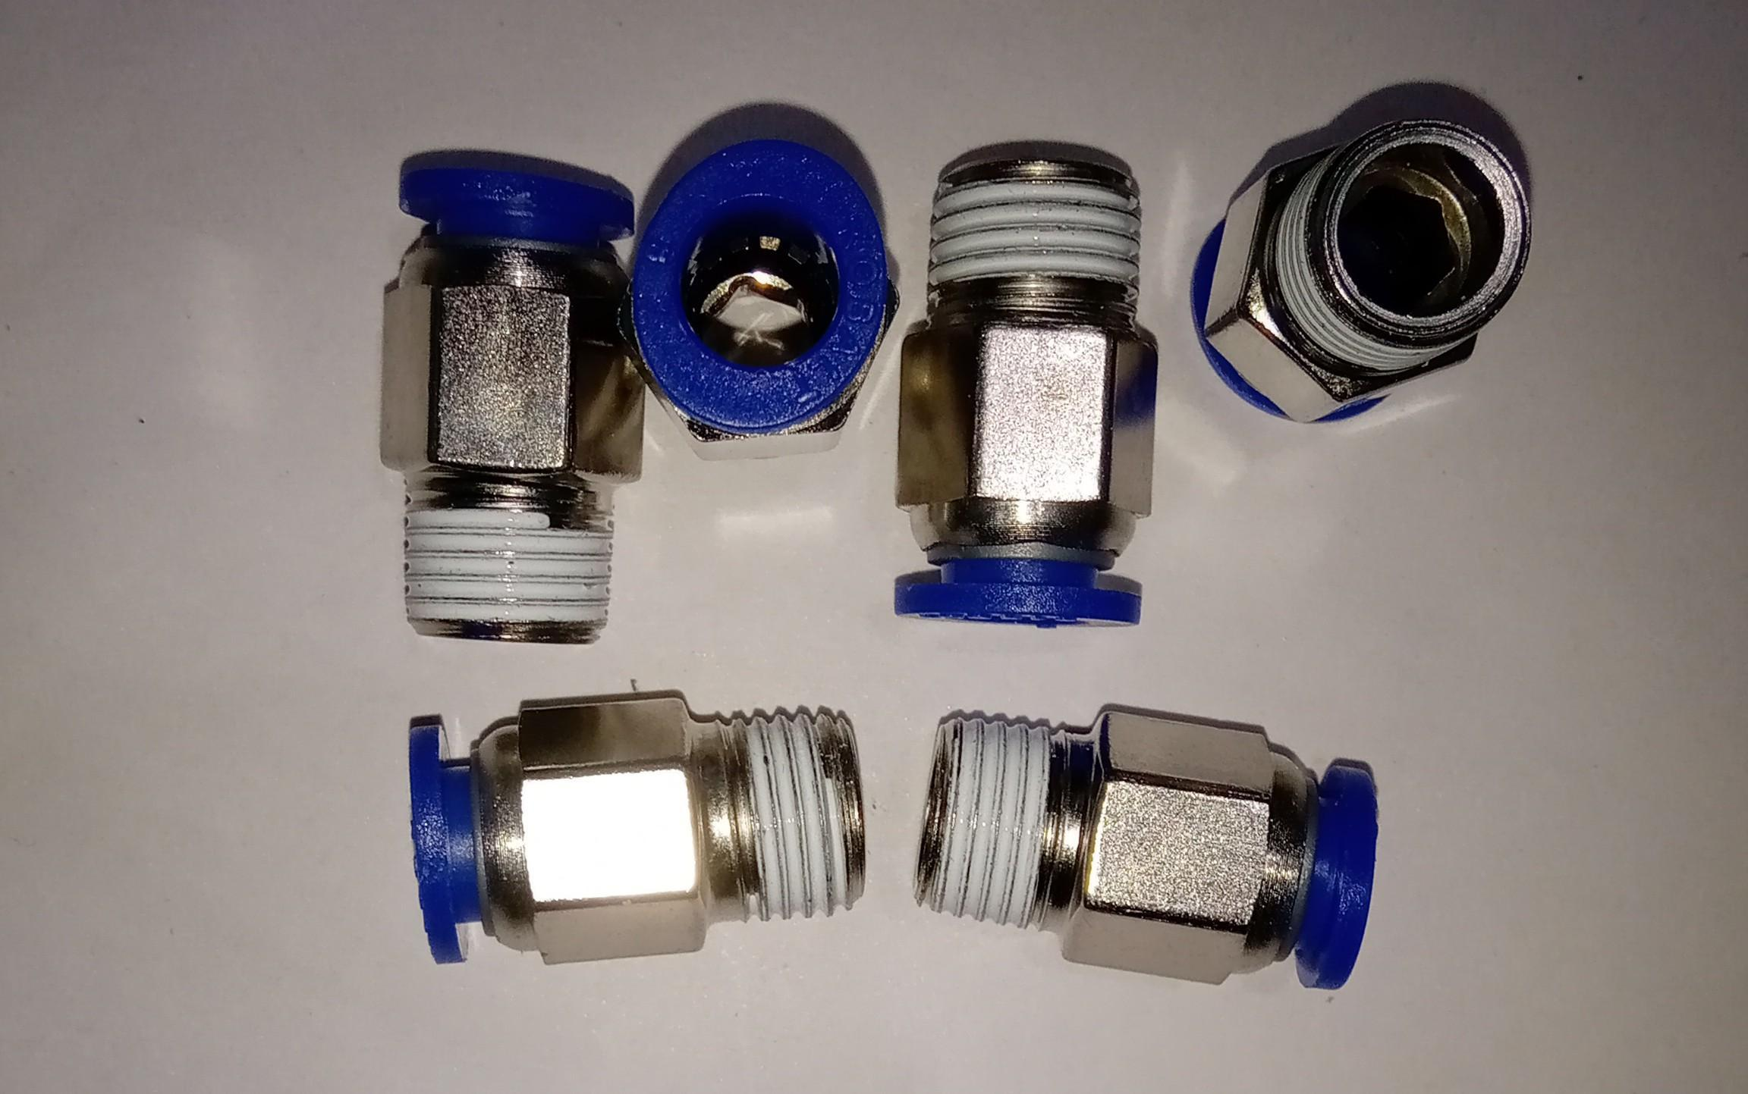

**4.5.4. Pipe Fitting Connections**

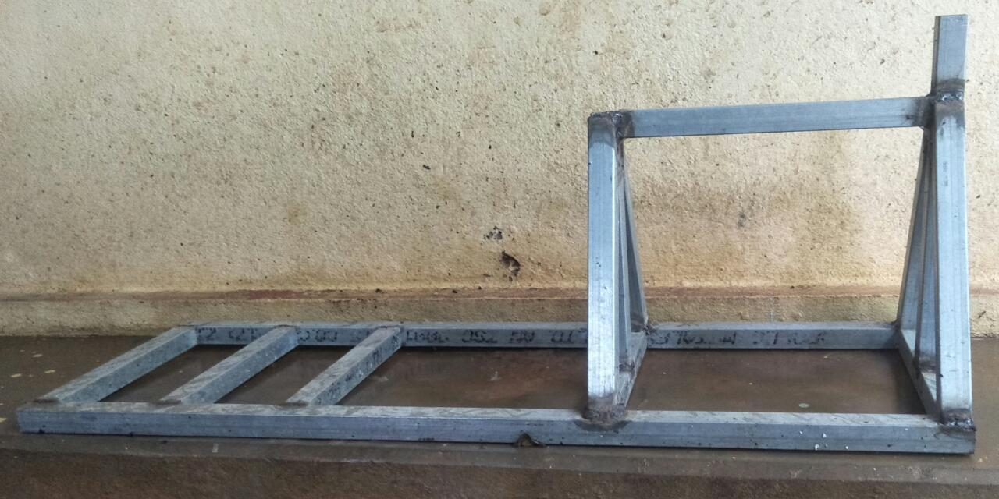

#### 4.5.5. Main Frame



#### 4.5.6. Shearing Blades

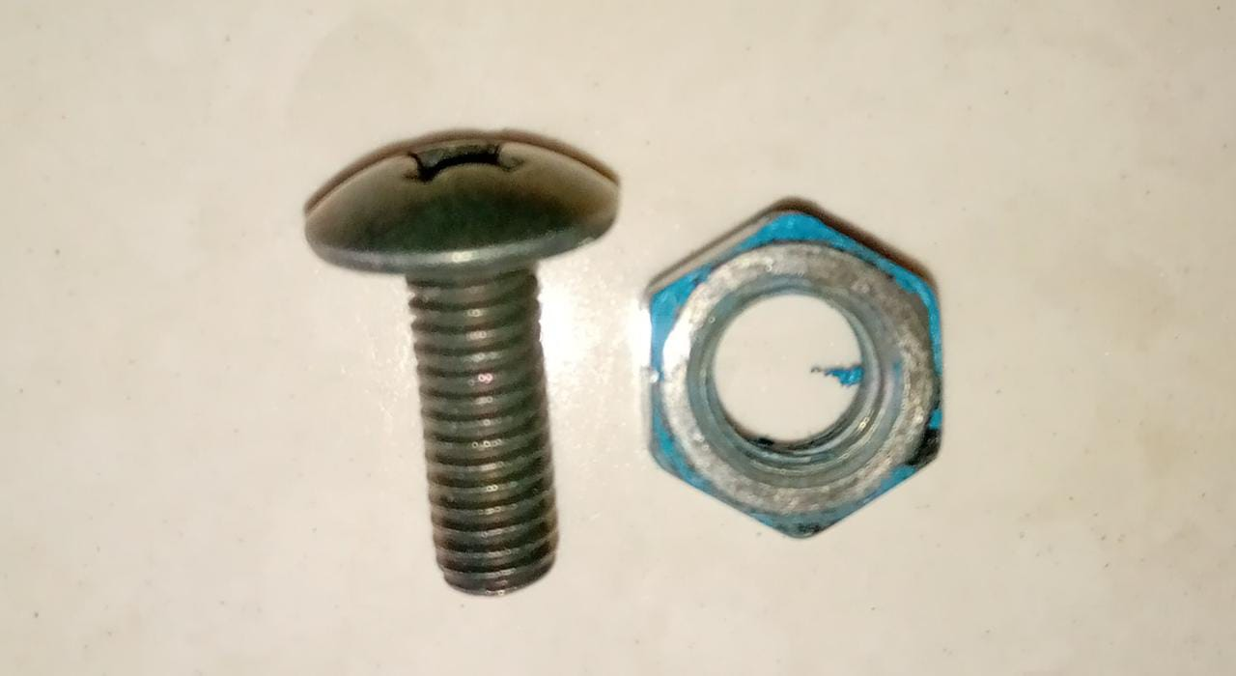

#### 4.5.7. Nut, Bolts

## CHAPTER 5. CALCULATION

**Data:**

sheet metal material used for cutting:- Aluminium

Thickness of sheet metal material:- 0.5mm

Length of Cut:- 25mm

Max shear strength of aluminum:- 30N/mm2

Cylinder diameter:-32mm

piston rod diameter:- 15mm

pressure applied by 12 volt compressor:- 10.34 bar

**Calculation:**

**1. Force required for cut the aluminium sheet metal:**

For sheet of 0.5 mm thickness,

Force required to cut the Sheet = L*t*Tmax

force required = 25×0.5×30

**force required= 375 N**

**Stripping force =10% -20% of cutting force**

**=37.5- 75 N**

where,

𝐿 = Length of periphery to be cut in mm

𝑆 = Sheet thickness in mm

𝑇𝑚𝑎𝑥 = Shear strength in N/mm2

**2. Max Force applied by the cylinder :**

*F* = (𝜋/4) × (*d*)2×*p*

*F* = (𝜋/4) × (32)2×(10.34/10)

***F* = 831.5 N**

where,

d = diameter of cylinder.

p = Pressure in bar. (1 bar = 0.1N/mm2)

F = Max Force applied by the cylinder.

**3. Cylinder Thrust:**

Cylinder thrust for double acting in forward stroke.

Cylinder thrust for double acting in return stroke -

F = (𝜋 /4) × (𝐷 – 𝑑)2 × 𝑃

F= (𝜋 /4) × (32-15 )2 ×(10.34/10)

**F =234.7 N**

where,

D = Diameter of bore in mm.

P = Pressure in bar. (1 bar = 0.1N/mm2)

d = Piston rod diameter in mm.

F = Cylinder Thrust.

**4. Theoretical air Consumption:**

𝐶 = {(π /4) × 𝐷2 × (P + 1) × L}/1000

*C =*{(π /4) × (3.2)2 × ((10.34/10) + 1) × 10}/1000

**C *=* 0.1635 litres**

where,

P = pressure in bar

D = Diameter of bore in cm.

L = Length of stroke in cm.

C = Theoretical air Consumption.

## CHAPTER 6. RESULTS AND DISCUSSIONS:

### 7.1 RESULT:

**Force required to cut the aluminium sheet metal: 375 N**

**Max force to cut the sheet : 831.5 N**

**Cylinder Thrust: 234.7 litres**

**Theoretical air Consumption: 0.1635 N**

### 7.2 DISCUSSION:

1. We discuss the problems face during the making of project.
2. Discussion about project working and construction was done before making it for betterment of the project.
3. Before Paper Publishing we made discussion on the project future ideology.

## CHAPTER 7. COSTING AND SCHEDULE

### 7.1 COSTING:

| SR NO | EQUIPMENTS | QUANTITY | PRICE |
| --- | --- | --- | --- |
| 1 | Double Acting Cylinder | 1 | 3000 |
| 2 | Direction Control Valve | 1 | 700 |
| 4 | Pipe | 1 | 999 |
| 5 | Pipe Fitting Connections | 1 | 399 |
| 6 | Main Frame | 18 feet | 432 |
| 7 | Shearing Blades | 1 | 150 |
| 8 | Nut, Bolts | 14 | 60 |
| 10 | Print |  | 510 |
| 11 | Paint | 2 | 80 |
| TOTAL | | | 6330 |

### 7.2 SCHEDULE:

| SR NO. | ACTIVITES | DATE |
| --- | --- | --- |
| 1 | SEARCH ON PROJECTS | 29/09/2020 |
| 2 | PROJECT APPROVAL | 04/10/2020 |
| 3 | PROJECT SYNOPSIS | 23/11/2020 |
| 4 | PPT ON PNEUMATIC SHEET METAL CUTTING MACHINE PROJECT | 27/05/2021 |
| 5 | PAPER PRESENTATION ON PNEUMATIC SHEET METAL CUTTING MACHINE PROJECT | 27/05/2021 |
| 6 | PUBLISHING OUR PAPER ON OUT PROJECT | 10/04/2021 |
| 7 | PAPER PUBLISHED | 14/04/2021 |
| 8 | PROJECT SUBMISSION |  |

## CHAPTER 8.GENERAL CONCLUSION

### 8.1. CONCLUSION:

Now we know that Pneumatic Shearing machine is very cheap as compared to hydraulic shearing machine. The range of the cutting thickness can be increased by arranging a high pressure compressor and installing more hardened blades. This machine is advantageous to small sheet metal cutting industries as they cannot afford the expensive hydraulic shearing machine. we also know the Max Force applied by the cylinder, Cylinder thrust and Theoretical air consumption of our project.

### 8.2. PROBLEMS FACED:

* Due to global pandemic covid-19 the equipment’s were not easily available in the market.
* The shipments were also delayed due to this situation.
* The situation made hard to meet and discuss about the project therefore we have to build the small prototype of the project in minimum parts.

### 8.3. LEARNING EXPERIENCE

* ‘TOLERANT’ this project was a group task and each member has their own and different views on the project. Listening to everyone’s view and accepting the best opinion for the benefit of the project was important.
* ‘TIME MANAGEMENT’ attending the lecture, doing the studies and managing the time for doing project was the most difficult task. But making the balance in both was successfully done.
* ‘MARKETING’ we got to know the difference prices of our project equipment’s and also learn to analysis the cost for the benefit of project.
* ‘COMMUNICATION’ while searching and discussing about the project we communicate with various members and professor for the project which lead to strengthen the skills of ours.

### 8.4 FUTURE SCOPE:

Pneumatic sheet cutting machine is a very versatile machine and has a lot of applications because of it flexibility and ease of doing operations. This machine can be converted into a punching machine by removing the blade and adding punching die to the end of the piston. By increasing the pressure, we can cut more sheets collectively. Because of it enormous use in industries higher production rate can be achieved by balancing the forces and making the design more compact.

Software and advance controlling systems can improve the machine’s performance. By replacing the pneumatic circuit with rack and pinion arrangement, it can be converted into rack and pinion operated machine. The electric motor air compressor can also be replaced by an IC engine installed compressor where we are deprived of electric energy.

In this machine, the ideal stroke wastes the air which moves out through the out port of control unit. In future, mechanism can be developed to use the air again for the working of cylinder. Thus in future there are so many modifications, which we can make to survive the huge global world of competition.

## LITERATURE CITED

### REFERENCES

[1] R.S. Khurmi, *Machine Design,* S. Chand & Co. Ltd., New Delhi 2005.

[2] O. P. Khanna Dhanpat, *Manufacturing Process,* Rai Pub. (P) Ltd. New Delhi

[3] R.K. Jain, *Workshop Technology,* Khanna Publishers Delhi

[4] S.R. Mujumdar. *Pneumatic System Principle & Maintenance* Tata McGraw-Hill Publishing Com. Ltd, West Patel Nagar, New Delhi

[5] Internet sites-

[1] <http://www.google.com/>

[2] https://www.engineersedge.com/

[3] http://www.efunda.com/

[4] http://www.mechanicalengineeringblog.com/

[6]Research paper-

[1]Suraj V Bhosale1, Gajanan S Ghute, Nikita H Dudhe, Ashish G Ingle, *“Design and Fabrication of Pneumatic Sheet Metal Cutting Machine”*, Volume 05, Jan-2018.

[2]Khagendra Barman, Md. Nesar Ali, Md Rayhan Hasnat,*“FABRICATION OF A PNEUMATIC SHEET METAL CUTTING MACHINE”*, Volume 01, Dec-2017.

[3]K Uday Kiran, V Naga Durga Ranjith, MD Rizwan Pasha, V.Vineela, Shaik Ismail, R Raj Kumar, Y Thomas Nikhil *“FABRICATION OF PNEUMATIC SHEET METAL SHEARING MACHINE”*, Volume: 07 , Mar 2020.

[4] Raj Reddy, *“Fabrication of Pneumatic Sheet Metal Cutter”,* ISSN No. : 0975-8364, Oct-2016.

[5] Prajwal Poojary, Nishanth V, Nikhil, Niranjan Karkera, Ganesh Kalagi, *“ Automated Pneumatic Sheet Metal Cutting Machine”,* Volume: 09, Apr-2018

[6] Aryan Pratihar, Adarsh Raunak, Ayog Kumar Rastogi, Aakash Sharma, Vikas Kumar Singla, *“Design and Fabrication of Pneumatic Sheet Metal Cutting and Punching Machine”,* Volume 09, July-2020

[7] K.Krantikumar, K.V.S.S.Saikiran, Jakkoju Sathish, *“Pneumatic Sheet Metal Cutting Machine”,* Volume 03, Mar-2012.

### PAPER PUBLISHED:

* Design and Application of PNEUMATIC SHEET METAL CUTTING MACHINE
* **International Journal of Research Publication and Reviews (IJRPR) Volume 2 Issue 4** **(2021)**

## ACKNOWLEDGEMENT

We feel great pleasure in submitting this project report on “PNEUMATIC SHEET METAL CUTTING MACHINE”. We wish to express a true sense of gratitude toward our project guide PROF. MESTRY M. P. who at very discrete steps in this project contributed with valuable guidance every problem that arose.

We wish to thank our PROF. EKNATH MANJREKAR for opening the doors of the department towards the realization of the project report. We would like to thank our Principal for this kind permission to complete this project.

We are also grateful for the Great PNEUMATIC SHEET METAL CUTTING MACHINE website and their members for helping and guiding us toward our project. We extend our thanks to staff members of the Mechanical Engineering Department and all my dear friends and parents who have extended their co-operation for the completion of this project.

Gopal Aravandekar

Bhushan Bambulkar

Pranav Gawas

Tejas Kadam